Creating or Managing YGL Users

If you are a Corporate level YGL user, or have had a Corporate level user assign you additional user/property permissions to your account--then you should have access to manage your YGL users via the ‘Account’ menu in YGL (See Figure 1)

Note: If you do not have access to manage users for your organization, but feel you should, please contact YGL Support via the Support button (pictured in Figure 1)

Figure 1

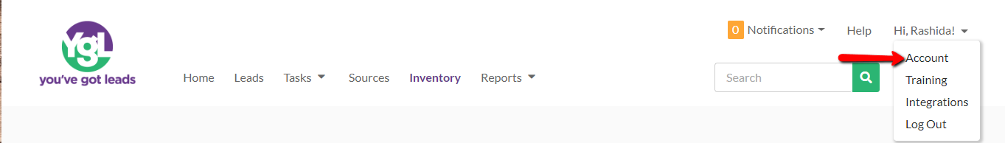

In the ‘Accounts menu should be two tabs. Click on the tab labeled ‘Users’ (See Figure 2)

Figure 2

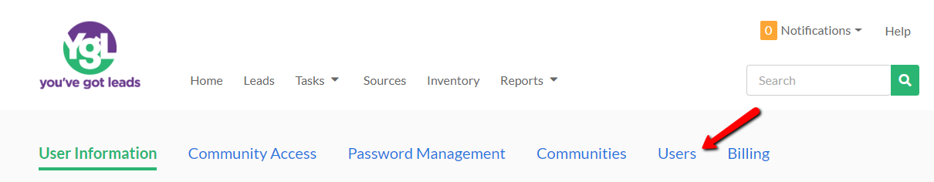

To add a new YGL user to your account, click on ‘Add New’ button (See Figure 3) or you can click on the ‘Active/Inactive’ drop down menu to manage current user’s active/inactive statuses if the user has already been created for your organization previously, and shows up in the list displayed in Figure 3.

Figure 3

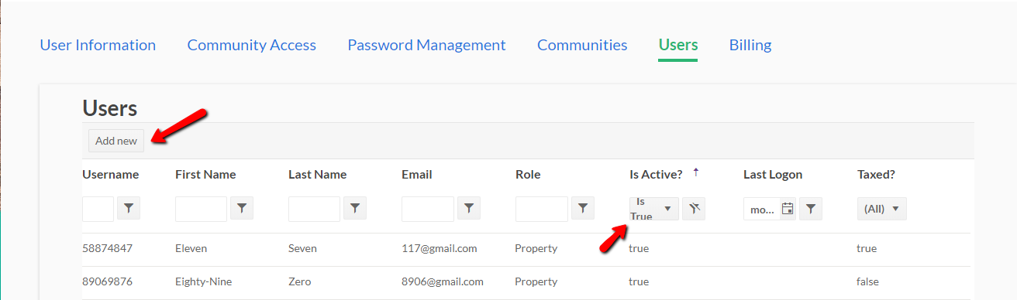

On the resulting pop-up window you can enter relevant information to create a new YGL user account (including username, first/last name, email address (required), and the role of the user (typically is set at the ‘Property’ level for most users). See Figure 4  Note: New users you create will have an introductory email sent to them in order for them to setup/self-manage their password for YGL. A valid email address is required! | Figure 4  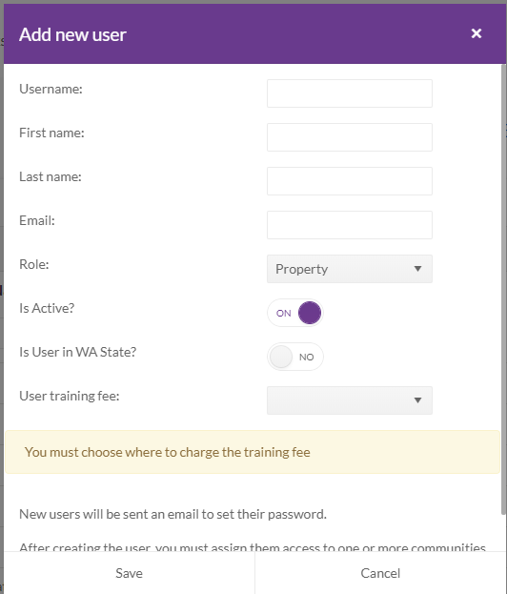

The following screen will appear after the user’s account was saved.  One or more communities will need to be assigned to the user account.  To do this, Choose the community name from the drop down list and click add (as shown in the example in Figure 5). | Figure 5  